Early Detection of Chili Leaf Diseases Using Convolutional Neural Network Based on Leaf Images

Author^{1*}, Author², Author³, Author⁴, Author⁵
^{1,2,3}Affiliation, Country, ⁴Affiliation, Country, ⁵Affiliation, Country
¹email@email.com, ²email@email.com, ³email@email.com, ⁴email@email.com, ⁵email@email.com

  *Corresponding Author | ABSTRACT  Chili plants (Capsicum sp.) are one of the important agricultural commodities in Indonesia with high economic value. However, chili productivity is often disrupted by leaf diseases such as leaf curl, yellow leaf, and leaf spot, which can significantly reduce crop yields. Conventional detection methods still rely on manual observation, which is less efficient and prone to errors. Therefore, this study aims to develop an early detection system for chili leaf diseases using a Convolutional Neural Network (CNN) based on leaf image data. The dataset consists of chili leaf images categorized into four classes: healthy, leaf curl, yellow leaf, and leaf spot. The research method includes data preprocessing, augmentation, model training, and evaluation using performance metrics such as precision, recall, and mean Average Precision (mAP). The results show that the proposed model achieves a precision of 0.75, recall of 0.53, and mAP@0.5 of 0.60. These results indicate that CNN is effective for image-based plant disease detection and has strong potential to support early detection systems in agriculture.
Article History:
Submitted: xx
Accepted: xx

Published: xx

Keywords:
Computer Vision; Convolutional Neural Network; Deep Learning; Image Classification; Plant Disease Detection
The Journal is licensed under a Creative Commons Attribution-NonCommercial 4.0 International (CC BY-NC 4.0).

INTRODUCTION
Chili plants (Capsicum sp.) are widely cultivated in Indonesia due to their high economic value and widespread consumption [1]. Chili also contains important nutrients beneficial for human health [2]. However, chili production often decreases due to plant diseases, especially leaf curl disease [3]. This disease causes leaves to curl, turn yellow, and inhibits plant growth, which significantly impacts crop yield. In addition to leaf curl disease, other common diseases such as yellow leaf and leaf spot also contribute to reduced productivity in chili plants [4].
Leaf curl disease is generally caused by viral infections such as Yellow Leaf Curl Virus (YLCV), which is transmitted by insect vectors like whiteflies [5]. The lack of early detection often results in delayed treatment, increasing production costs and reducing farmer income. Early detection of plant diseases is essential to prevent further spread and minimize economic losses [6].
Traditional detection methods rely on manual observation, which is subjective and inefficient. With the advancement of technology, artificial intelligence, particularly deep learning, offers a solution for automatic detection [7]. Deep learning has shown strong performance in image-based classification compared to traditional methods [7]. Convolutional Neural Network (CNN) is one of the most effective methods for image classification tasks due to its ability to extract features automatically [8]. Previous studies have also demonstrated that CNN-based approaches can effectively detect plant diseases [6].
However, many existing studies are conducted under controlled conditions and may not perform well in real-world environments. Therefore, this study proposes an early detection system for chili leaf diseases using CNN based on image data to improve detection accuracy and efficiency.

LITERATURE REVIEW

Image Processing and Computer Vision in Agriculture
Image processing and computer vision have become increasingly important in modern agriculture, particularly in plant disease detection. Digital image processing is used to analyze and manipulate images to extract meaningful information [9]. A digital image consists of pixels that represent color intensity and spatial structure [10]. Various techniques such as segmentation, feature extraction, and classification are applied to analyze images [11].
Computer vision enables machines to interpret visual data similarly to humans and is widely used in agricultural applications such as crop monitoring and disease detection [12]. Compared to traditional methods, image-based approaches provide faster, more consistent, and scalable solutions.

Machine Learning and Deep Learning Approaches
Machine learning is a subset of artificial intelligence that enables systems to learn patterns from data and make predictions without being explicitly programmed [13]. Traditional machine learning methods rely on handcrafted features, which often limit performance in complex environments.
Deep learning is an advanced approach that uses multi-layer neural networks to automatically learn feature representations from raw data [7]. This method has demonstrated superior performance in image classification tasks [7].

Convolutional Neural Network (CNN)
Convolutional Neural Network (CNN) is one of the most widely used deep learning architectures for image analysis [8]. CNN is specifically designed to process image data by utilizing convolutional operations to extract spatial features.
A typical CNN architecture consists of convolutional layers, activation functions, pooling layers, and fully connected layers [14]. CNN can automatically learn hierarchical features, from low-level patterns such as edges and textures to high-level patterns such as shapes and structures, making it highly effective for plant disease classification.
Recent studies have demonstrated that deep learning models, particularly Convolutional Neural Networks (CNN), continue to achieve high performance in image classification tasks across various domains, including agriculture [15], [16]. Advanced architectures such as EfficientNet and hybrid CNN models have been shown to improve classification accuracy while maintaining computational efficiency [17]. In addition, transfer learning techniques have been widely used to enhance model performance, especially when dealing with limited datasets [18]. Furthermore, data augmentation and dataset balancing techniques play a crucial role in improving model generalization and reducing overfitting [19]. Evaluation methods based on confusion matrix metrics remain widely adopted to assess classification performance and ensure reliable model validation [20].

Dataset and Data Augmentation
The quality and quantity of the dataset play a critical role in determining the performance of deep learning models [21]. A good dataset should represent various conditions such as lighting, orientation, and environmental variations to improve model generalization.
Data augmentation techniques are used to increase dataset diversity and improve model robustness. Common augmentation methods include rotation, flipping, scaling, and translation.

Evaluation Metrics for Classification Models
Model performance is evaluated using metrics such as accuracy, precision, recall, and F1-score, which are derived from the confusion matrix [22]. These metrics provide a comprehensive evaluation of classification performance, especially in imbalanced datasets. Convolutional Neural Networks (CNN) have been widely applied in image classification tasks and have demonstrated high accuracy in pattern recognition [23]. In addition, recent studies show that deep learning models are capable of learning complex patterns from large-scale datasets and improving classification performance [24]. Furthermore, data augmentation techniques are commonly used to increase dataset diversity and enhance model generalization in deep learning applications [25].

Previous Research and Research Gap
Previous studies have shown that CNN-based approaches can effectively detect plant diseases with high accuracy [6]. However, many of these studies are conducted under controlled conditions and may not perform well in real-world environments. In addition, some studies use limited datasets or focus only on specific types of diseases.
Therefore, there is a need for research that utilizes real-world datasets and develops models that are both effective and practical for implementation. This study addresses these gaps by applying CNN to detect chili leaf diseases using data collected from real conditions.

METHOD

Research Design
This study adopts a quantitative approach using supervised learning based on Convolutional Neural Network (CNN) for image classification. The objective is to develop an automated system capable of detecting chili leaf curl disease based on digital leaf images. The overall research process consists of several stages, including data collection, preprocessing, model development, training, and evaluation.

Data Collection
The dataset used in this study consists of chili leaf images collected directly from local farmers. The images are categorized into four classes: healthy leaves, leaf curl, yellow leaf, and leaf spot. Data collection was carried out under real field conditions to ensure that the dataset represents variations in lighting, background, and leaf orientation. Each image was manually labeled to ensure the accuracy of class annotations. Examples of the dataset used in this study are shown in Fig. 1.

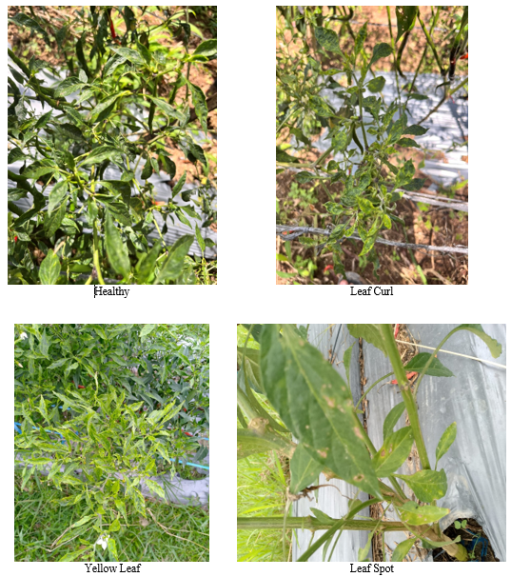
Fig. 1. Sample images of chili leaf dataset (healthy, leaf curl, yellow leaf, and leaf spot)
The dataset is divided into three subsets, namely training data (70%), validation data (20%), and testing data (10%). This data splitting is used to train the model, tune hyperparameters, and evaluate model performance objectively.

Data Preprocessing
Before training the model, preprocessing is performed to standardize the input data and improve model performance. The preprocessing steps include:
- Image Resizing
All images are resized into a fixed dimension to ensure uniformity and reduce computational complexity.
- Normalization
Pixel values are scaled to a range of 0–1 to accelerate the training process and improve convergence.
- Data Cleaning
Images that are blurry, duplicated, or irrelevant are removed to maintain dataset quality.

Data Augmentation
To increase the diversity of the dataset and prevent overfitting, data augmentation techniques are applied. These techniques artificially expand the dataset by generating variations of existing images. The augmentation methods used in this study include:
- Rotation
- Horizontal flipping
- Vertical flipping
These transformations help the model learn invariant features and improve its ability to generalize under different conditions.

CNN Model Architecture
The model used in this study is a Convolutional Neural Network (CNN) designed for multi-class image classification. The architecture consists of several main layers:

1. Convolutional Layer
Extracts important features from input images using filters.

2. Activation Function (ReLU)
Introduces non-linearity to enable the model to learn complex patterns.

3. Pooling Layer
Reduces the spatial dimensions of feature maps and prevents overfitting.

4. Fully Connected Layer
Processes extracted features and performs classification.

5. Output Layer
Produces final predictions in the form of class probabilities (healthy, leaf curl, yellow leaf, and leaf spot).

The model is implemented using TensorFlow/Keras framework.

Model Training
The training process involves feeding the training dataset into the CNN model and adjusting the model parameters to minimize classification error. The training configuration includes:

1. Optimizer: Adam
2. Loss Function: Categorical Crossentropy
3. Epochs: determined based on convergence
4. Batch size: adjusted according to system capability

During training, the model performs forward propagation to generate predictions and backpropagation to update weights iteratively. Validation data is used to monitor model performance and prevent overfitting.

Model Evaluation
After training, the model is evaluated using the testing dataset to measure its performance on unseen data. The evaluation is conducted using several metrics derived from the confusion matrix:
- Accuracy: Measures overall prediction correctness
- Precision: Measures the accuracy of positive predictions
- Recall: Measures the ability to detect positive cases
- F1-score: Harmonic mean of precision and recall
These metrics provide a comprehensive assessment of the model’s classification performance.

System Workflow
The overall workflow of the proposed system can be described as follows:
1. Input chili leaf image
2. Preprocessing and normalization
3. Feature extraction using CNN
4. Classification into one of four classes (healthy, leaf curl, yellow leaf, or leaf spot)
5. Output prediction result
This workflow enables automatic and efficient detection of chili leaf diseases.

RESULT
The training and validation performance of the CNN model is illustrated in Fig. 2. The training results show that the loss values decrease consistently as the number of epochs increases. In addition, the precision improves and reaches approximately 0.75, while the recall stabilizes around 0.53. The mAP@0.5 also increases and reaches approximately 0.60. These results indicate that the model successfully learns relevant features from the dataset and improves its performance over time.
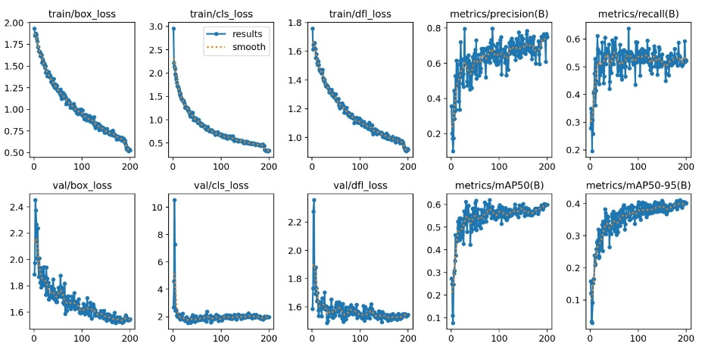
Fig. 2. Training and validation performance of the CNN model

Performance Table
Table 1 Model Performance Evaluation
Class | Precision | Recall | mAP@0.5
Leaf Spot | 0.86 | 0.86 | 0.86
Leaf Curl | 0.55 | 0.55 | 0.55
Yellow Leaf | 0.38 | 0.38 | 0.38
Healthy | 0.71 | 0.71 | 0.71
To further analyze the classification performance and identify patterns of misclassification among classes, the normalized confusion matrix is presented in Fig. 3.
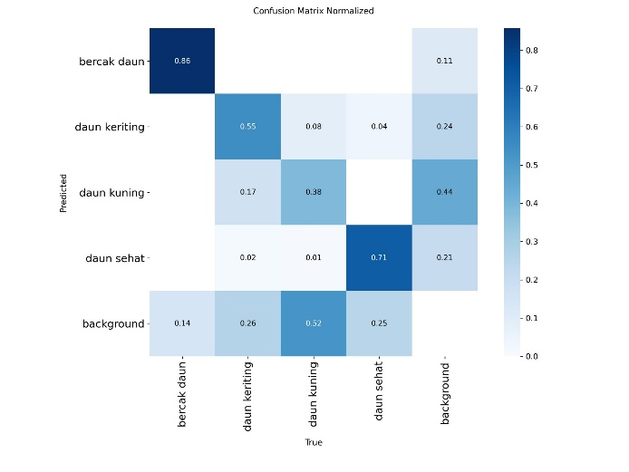
Fig. 3. Normalized Confusion Matrix of CNN Model

Confusion Matrix Analysis
The confusion matrix results indicate that the model performs very well in classifying the leaf spot class, achieving the highest accuracy of approximately 0.86. The healthy leaf class also shows good performance with an accuracy of around 0.71. Meanwhile, the leaf curl class demonstrates moderate performance with an accuracy of approximately 0.55. The yellow leaf class shows relatively low performance, with an accuracy of around 0.38, indicating difficulty in distinguishing this class from others. Some misclassification occurs between the leaf curl and yellow leaf classes, suggesting that these classes share similar visual characteristics such as color and texture patterns.

DISCUSSION
The results of this study demonstrate that the proposed Convolutional Neural Network (CNN) model is capable of performing multi-class classification of chili leaf diseases with reasonably good performance. Based on the evaluation metrics, the model achieves a precision of 0.75, recall of 0.53, and mAP@0.5 of 0.60. These results indicate that the model is able to correctly identify a significant portion of the disease classes, although there is still room for improvement, particularly in terms of recall.
The training process shows a consistent decrease in loss values and a gradual improvement in performance metrics such as precision and mAP, indicating that the model successfully learns meaningful features from the dataset and converges without severe overfitting. The use of preprocessing and data augmentation techniques also contributes to improving the model's generalization ability under varying conditions.
From the confusion matrix analysis, it is evident that the model performs very well on the leaf spot class, achieving the highest accuracy. This is likely due to the distinct visual characteristics of leaf spot disease, such as clear circular patterns, which are easier for the CNN to learn. Similarly, the healthy leaf class also shows good performance, indicating that the model can effectively differentiate between healthy and diseased leaves.
However, the performance of the model is relatively lower for the leaf curl and yellow leaf classes. The leaf curl class shows moderate performance, while the yellow leaf class has the lowest accuracy among all classes. This can be attributed to the similarity in visual features between these classes, such as overlapping color patterns and subtle texture differences. As a result, the model struggles to clearly distinguish between these classes. Some misclassification occurs between the leaf curl and yellow leaf classes, indicating that these classes share similar visual characteristics, which affects the overall classification performance.
Compared to previous studies that reported higher accuracy using CNN-based approaches, the performance of this study is slightly lower. However, this result reflects more realistic conditions, as the dataset used includes variations in lighting, orientation, and environmental conditions. Therefore, the model's performance can still be considered acceptable for practical applications.
Despite these promising results, several limitations are identified. First, the dataset size is relatively limited, which affects the model's ability to generalize. Second, the model architecture used is relatively simple, which may limit its capacity to learn complex features. Future work can focus on improving performance by increasing dataset size, applying more advanced architectures such as ResNet, and optimizing hyperparameters.
Overall, this study demonstrates that CNN-based models have strong potential for early detection of chili leaf diseases, although further improvements are needed to enhance accuracy and robustness in real-world conditions.

CONCLUSION
This study successfully develops a CNN-based system for early detection of chili leaf diseases, achieving a precision of 0.75, recall of 0.53, and mAP@0.5 of 0.60. These results indicate that the model is capable of performing classification tasks with reasonably good performance. The use of CNN demonstrates strong potential for supporting automated disease detection in agriculture. However, the model still requires improvement, particularly in distinguishing visually similar classes. Future work can focus on increasing dataset size and optimizing the model to improve overall performance.

REFERENCES

[1] N. Inaya, S. Meriem, and M. Masriany, “Identifikasi morfologi penyakit tanaman cabai (Capsicum sp.) yang disebabkan oleh patogen dan serangan hama lingkup kampus UIN Alauddin Makassar,” Filogeni: Jurnal Mahasiswa Biologi, vol. 2, pp. 8–14, Apr. 2022, doi: 10.24252/filogeni.v2i1.27092.
[2] K. L. Wali, H. R. Amanupunnyo, and G. N. C. Tuhumury, “Kajian Keberadaan Jenis-Jenis Penyakit-penyakit Tanaman Penting pada Cabai (Capsicum sp.),” JURNAL PERTANIAN KEPULAUAN, vol. 9, pp. 42–49, Mar. 2025, doi: 10.30598/jpk.2025.9.1.42.
[3] A. Suyanto, A. Masulili, E. Ekawati, S. Setiawan, I. Astar, and R. Y. Ayen, “Budidaya Cabe Rawit Tanpa Terserang Penyakit Keriting Daun di Kelompok Tani Horti Maju Desa Punggur Kecil, Kec. Sungai Kakap, Kab. Kubu Raya,” Jurnal Abdi Masyarakat Indonesia, vol. 3, pp. 1271–1276, Jul. 2023, doi: 10.54082/jamsi.857.
[4] J. Homepage, Y. Devianto, S. Dwiasnati, B. Sukowo, A. Fauzi, and K. A. Baihaqi, “Penerapan Technique for Order Performance by Similarity to Ideal Solution (TOPSIS) untuk Mendiagnosa Penyakit Bercak Daun Cabai,” MALCOM: Indonesian Journal of Machine Learning and Computer Science, vol. 3, no. 2, pp. 136–142, Sep. 2023, doi: 10.57152/MALCOM.V3I2.850.
[5] A. Gita Fakhira, D. Mindrati Fardhani, and I. Afifah Nugraheni, “Serangan Yellow Leaf Curl Virus (YLCV) pada tanaman cabai (Capsicum spp.) di Daerah Nogotirto.”
[6] M. Rizki Ridhwan and H. Hudori, “Identifikasi Penyakit Virus Kuning pada Tanaman Cabai dengan Pendekatan CNN,” Jurnal SAINTEKOM (Sains dan Teknologi Komputasi), vol. 2, no. 1, pp. 66–78, Apr. 2026, doi: 10.36350/jskom.v2i1.81.
[7] A. Raup, W. Ridwan, Y. Khoeriyah, S. Supiana, and Q. Y. Zaqiah, “Deep Learning dan Penerapannya dalam Pembelajaran,” JIIP - Jurnal Ilmiah Ilmu Pendidikan, vol. 5, no. 9, pp. 3258–3267, Sep. 2022, doi: 10.54371/JIIP.V5I9.805.
[8] I. Suhardin, A. Patombongi, and A. M. Islah, “MENGIDENTIFIKASI JENIS TANAMAN BERDASARKAN CITRA DAUN MENGGUNAKAN AlGORITMA CONVOLUTIONAL NEURAL NETWORK,” Simtek : jurnal sistem informasi dan teknik komputer, vol. 6, pp. 100–108, Oct. 2021, doi: 10.51876/simtek.v6i2.101.
[9] F. Marpaung, F. Aulia, N. Suryani SKom, and R. Cyra Nabila SKom, COMPUTER VISION DAN PENGOLAHAN CITRA DIGITAL. [Online]. Available: www.pustakaaksara.co.id
[10] J. Dengan Operator and S. Dan, “STUDI PEMBANDING DETEKSI TEPI (EDGE DETECTION) CITRA.”
[11] H. Kusumo, “Aplikasi pengenalan pola citra tanda tangan dengan metode Speeded-Up Robust Features (SURF) pada single board computer beaglebone black: studi kasus Pusat Penelitian Fisika (P2F) Lipi, Serpong,” 2015, Accessed: Jul. 22, 2025. [Online]. Available: https://repository.uinjkt.ac.id/dspace/handle/123456789/28544
[12] M. Hanum and S. Artikel, “Implementasi Teknik Embossing pada Pengenalan Plat Kendaraan untuk Identifikasi Otomatis Berbasis OpenCV,” JoMMiT : Jurnal Multi Media dan IT, vol. 8, no. 1, pp. 062–068, Sep. 2024, doi: 10.46961/JOMMIT.V8I1.1361.
[13] R. Diana, H. Warni, and T. Sutabri, “PENGGUNAAN TEKNOLOGI MACHINE LEARNING UNTUK PELAYANAN MONITORING KEGIATAN BELAJAR MENGAJAR PADA SMK BINA SRIWIJAYA PALEMBANG,” JUTEKIN (Jurnal Teknik Informatika), vol. 11, no. 1, Jun. 2023, doi: 10.51530/jutekin.v11i1.709.
[14] R. J. Gunawan, B. Irawan, and C. Setianingsih, “Pengenalan Ekspresi Wajah Berbasis Convolutional Neural Network Dengan Model Arsitektur Vgg16,” https://openlibrarypublications.telkomuniversity.ac.id/index.php/engineering/article/view/16400.
[15] I. D. Mienye and T. G. Swart, “A Comprehensive Review of Deep Learning: Architectures, Recent Advances, and Applications,” Information 2024, Vol. 15, Page 755, vol. 15, no. 12, p. 755, Nov. 2024, doi: 10.3390/INFO15120755.
[16] S. Minaee, Y. Boykov, F. Porikli, A. Plaza, N. Kehtarnavaz, and D. Terzopoulos, “Image Segmentation Using Deep Learning: A Survey,” IEEE Trans. Pattern Anal. Mach. Intell., vol. 44, no. 7, pp. 3523–3542, Jul. 2022, doi: 10.1109/TPAMI.2021.3059968.
[17] K. Muthulakshmi and M. Jayalakshmi, “Rethinking model of EfficientNet-B9 for brain tumor classification: A high-precision deep learning approach,” Results in Engineering, vol. 28, p. 107984, Dec. 2025, doi: 10.1016/J.RINENG.2025.107984.
[18] M. Iman, H. R. Arabnia, and K. Rasheed, “A Review of Deep Transfer Learning and Recent Advancements,” Technologies 2023, Vol. 11, Page 40, vol. 11, no. 2, p. 40, Mar. 2023, doi: 10.3390/TECHNOLOGIES11020040.
[19] W. Zeng and W. Zeng, “Image data augmentation techniques based on deep learning: A survey,” Mathematical Biosciences and Engineering 2024 6:6190, vol. 21, no. 6, pp. 6190–6224, 2024, doi: 10.3934/MBE.2024272.
[20] K. Riehl, M. Neunteufel, and M. Hemberg, “Hierarchical confusion matrix for classification performance evaluation,” J. R. Stat. Soc. Ser. C Appl. Stat., vol. 72, no. 5, pp. 1394–1412, Dec. 2023, doi: 10.1093/JRSSSC/QLAD057.
[21] G Hermawan, “Memahami Peran Dataset dalam Penelitian Kecerdasan Buatan: Kualitas, Aksesibilitas, dan Tantangan,” researchgate.netG HermawanPreprint, Oct, 2024•researchgate.net, 2024, Accessed: Jul. 22, 2025. [Online]. Available: https://www.researchgate.net/profile/Galih-Hermawan/publication/384863552_Memahami_Peran_Dataset_dalam_Penelitian_Kecerdasan_Buatan_Kualitas_Aksesibilitas_dan_Tantangan/links/670a921affe5b72812455d04/Memahami-Peran-Dataset-dalam-Penelitian-Kecerdasan-Buatan-Kualitas-Aksesibilitas-dan-Tantangan.pdf
[22] P. Fergus and C. Chalmers, “Performance Evaluation Metrics,” pp. 115–138, 2022, doi: 10.1007/978-3-031-04420-5_5.
[23] M. Ucan, B. Kaya, and M. Kaya, “Multi-Class Gastrointestinal Images Classification Using EfficientNet-B0 CNN Model,” 2022 International Conference on Data Analytics for Business and Industry, ICDABI 2022, pp. 146–150, 2022, doi: 10.1109/ICDABI56818.2022.10041447.
[24] A. Khan et al., “A survey of the vision transformers and their CNN-transformer based variants,” Artificial Intelligence Review 2023 56:3, vol. 56, no. 3, pp. 2917–2970, Oct. 2023, doi: 10.1007/S10462-023-10595-0.
[25] K. Fahd and S. J. Miah, “Effectiveness of data augmentation to predict students at risk using deep learning algorithms,” Social Network Analysis and Mining 2023 13:1, vol. 13, no. 1, pp. 113-, Sep. 2023, doi: 10.1007/S13278-023-01117-5.

